PROFESSIONAL BIOGRAPHY OF FLOYD A. KEITH

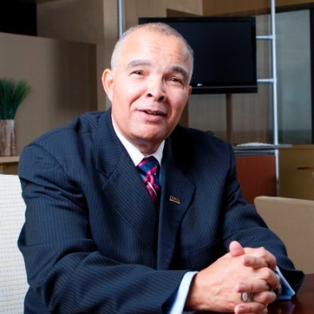

Floyd Keith has accumulated 54 years of service and expertise in both the sports and business professions; with 34 of those years in high level management. While serving as the Senior Director for Racial and Social Justice for YWCA Greater Lafayette, he developed and implemented the organizations first Diversity Education Program consisting of 16 workshops and the highly regarded Intercultural Development Inventory (IDI) component. Simultaneously, he remained the CEO of PPA (Planned Positive Attitude) Professional Services which provides services in professional development, diversity and inclusion and motivational speaking.
Mr. Keith held the position of sales manager for the Indianapolis Marriott East for 2 years (2018-2020) before the onset of the Covid 19 pandemic. During that span of time he accomplished the following for the Indianapolis Marriott East:
- Negotiated $862,291 in contracted room revenue
- Negotiated $321,933 in contracted food and beverage minimums
Floyd notably served 12 years as the Executive Director of the Black Coaches and Administrators from 2001-2013 following his decorated Division I collegiate football coaching career of 30 years
Floyd was appointed to the BCA in 2001. During his tenure, the BCA reinforced its position as the preeminent force for the social consciousness of ethnicity in American sports while increasing paid membership from 172 to over 5,500. The number of corporate sponsors grew from 1 to a high of 26 in 2011.
From 2002-2006, Floyd led the contractual negotiations for the securing of event promoters for 8 BCA Invitational and Classic pre-season basketball events and 5 pre-season exempt football events. Under his leadership, the BCA exceeded the $1M mark in fund raising on 4 occasions.
Keith conducted collaborative diversity and inclusion efforts known as “Equity in Hiring Summits”” from 2002 to 2005. These summits were dedicated to the resolution of the inequities in the hiring of ethnic minorities for head coaching and administrative athletic positions on the intercollegiate level. The nationally acclaimed BCA “Hiring Report Card” was a direct result of these summits. Under Floyd’s leadership, the BCA objectively influenced the way intercollegiate searches are conducted in America. Since the initial 2003 BCA hiring report for football, there was a 600% increase in the number of FBS head football coaches.
Floyd is nationally recognized for the development of the NCAA-BCA “Achieving Coaching Excellence Program” for collegiate basketball coaches. “A.C.E” was a professional development program made possible through a matching grant from the NCAA. The program was designed for the advancement of minority basketball coaches to become head coaches. Of 164 past participants during his tenure with BCA, over 50 participants became head coaches.
Floyd has received numerous national honors. In 2004, Sports Illustrated recognized him as one of “The 101 Most Influential Minorities in Sports”. Black Enterprise named him as one of the “50 Most Powerful Blacks in Sports” in 2005. The All-American Football Foundation honored him as the 2004 Executive Director of the Year. Mr. Keith served six years (2005-2012) on the “Honors Court of the National Football Foundation and College Football Hall of Fame”. In 2013, he was recognized by the Rainbow/Push Coalition with the “2013 Trailblazer in Sports” award. In 2021, Floyd was presented the distinguished “2021 NCAA Legacy Award” for his career achievements in coaching, diversity and inclusion and community service; and in 2022, the 2022 Thurgood Marshall Legacy Award from the U.S. Minority Contractors Association again for his successes in coaching, diversity and inclusion accomplishments and his community service.
His coaching honors include 8 NCAA and AFCA appointments, 3 presidential positions and 2 conference chairmanships. He earned conference “Coach of the Year” on 3 separate occasions, including the “1995 New England Coach of the Year in Division 1 Football”. The National Consortium for Academics and Sports awarded him the “2007 Giant Steps Award for Coaching”. The All-American Football Foundation honored him in 2005 with the Johnny Vaught Outstanding Coach Award. The Alliance for Women Coaches awarded him the Bigger Picture Award in June 2013.
Coach Keith served 7 years as the Head Football Coach for the University of Rhode Island. Prior to URI, he was the quarterback coach for 9 years at Indiana University. While at IU, he coached 3 NFL Quarterbacks; highlighted by, Trent Green. Floyd also served as the Head Football Coach at Howard University for 4 years, which was preceded by five years as an assistant at the University of Colorado. His collegiate coaching career began as a 21-year-old full-time assistant at Miami University, where he is listed in the renowned Miami University “Cradle of Coaches”.
In 2003, he was inducted into the Ohio Northern University Athletic Hall of Fame and was recognized as an ONU Distinguished Alumni in 2008. In 2008, Floyd was inducted into the Memorial High School Alumni Hall of Fame. He graduated from ONU in 1970 with a Bachelor of Science in Education.
The Keith family is comprised of his wife, Dr. Nicole R. Keith, Executive Associate Dean the Indiana University (Bloomington) School of Public Health and recently completed her tenure as President of the American College of Sports Medicine. They are proud parents of four: Kenyari (29), Imani (26), Mikia (23) and Kailan (21).

